Project Planning Basics
A "Project" is a set of activities which ends with specific accomplishment and which has (1) Non-routine tasks, (2) Distinct start/finish dates, and (3) Resource constraints (time/money/people/equipment).
"Tasks" are activities, which must be completed to achieve project goal. Break the project into tasks and subtasks. Tasks have start and end points, are short relative to the project and are significant (not "going to library", but rather, "search literature"). Use verb-noun form for naming tasks, e.g. "create drawings" or "build prototype". Use action verbs such as "create", "define" and "gather" rather than "will be made". Each task has a duration. Very difficult to estimate durations accurately. Doubling your best guess usually works well.
"Milestones" are important checkpoints or interim goals for a project. Can be used to catch scheduling problems early. Name by noun-verb form, e.g. "report due", "parts ordered", "prototype complete".
Your plan will evolve so be flexible and update on a regular basis. It also helps to identify risk areas for project, for example, things you don't know how to do but will have to learn. These are risky because you may not have a good sense for how long the task will take. Or, you may not know how long it will take to receive components you purchased for a project.

Work Breakdown Statement
A work breakdown statement (WBS) is a categorized list of tasks with an estimate of resources required to complete the task. An example WBS appears below.

WBS  # | Task  Description | Est  Person  -Hrs | Who | Resources | M&S
5 | Profile motor power
5.1 | Design test stand | 20 | SE, JM | Pro/E
5.2 | Build test stand | 15 | SE, JM | Frame & brake parts | $35
5.3 | Test 3 motors | 3 | SE, JM | Stroboscope | $75
5.4 | Plot torque vs. speed | 2 | JM | Excel
(M&S = Materials & Supplies)

Gantt Chart Basics
Gantt charts are a project planning tool that can be used to represent the timing of tasks required to complete a project. Because Gantt charts are simple to understand and easy to construct, they are used by most project managers for all but the most complex projects.
In a Gantt chart, each task takes up one row. Dates run along the top in increments of days, weeks or months, depending on the total length of the project. The expected time for each task is represented by a horizontal bar whose left end marks the expected beginning of the task and whose right end marks the expected completion date. Tasks may run sequentially, in parallel or overlapping.
As the project progresses, the chart is updated by filling in the bars to a length proportional to the fraction of work that has been accomplished on the task. This way, one can get a quick reading of project progress by drawing a vertical line through the chart at the current date. Completed tasks lie to the left of the line and are completely filled in. Current tasks cross the line and are behind schedule if their filled-in section is to the left of the line and ahead of schedule if the filled-in section stops to the right of the line. Future tasks lie completely to the right of the line.
In constructing a Gantt chart, keep the tasks to a manageable number (no more than 15 or 20) so that the chart fits on a single page. More complex projects may require subordinate charts which detail the timing of all the subtasks which make up one of the main tasks. For team projects, it often helps to have an additional column containing numbers or initials which identify who on the team is responsible for the task.
Often the project has important events which you would like to appear on the project timeline, but which are not tasks. For example, you may wish to highlight when a prototype is complete or the date of a design review. You enter these on a Gantt chart as
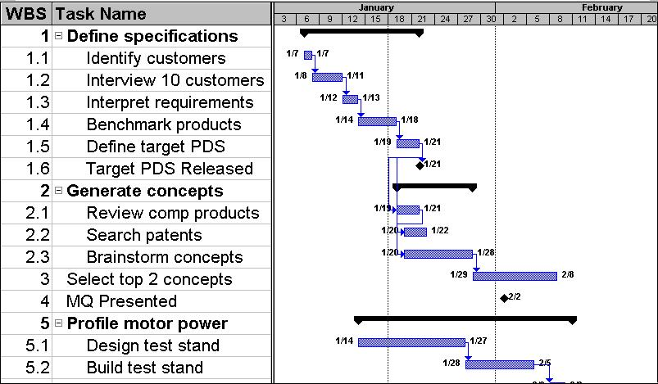
We strongly recommend that you use MS Project to create your Gantt charts, if nothing else because it will give you experience using this important package.
.

